**Dynamic Objects - Basics**

**5 Steps:**

1. Declare a global variable of that object
2. “Create” the object (instantiate by call the Create method)
3. Assign values to the object’s properties
4. Create any procedure for* the object (OnClick method)
5. Assign your method to the object’s events.

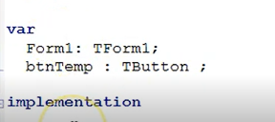**STEP 1: Declare global variable**

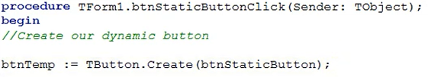**STEP 2: Create the object**

**STEP 3: Assign values to the object’s properties**

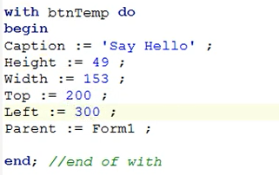

**STEP 4: Create procedure for the method**

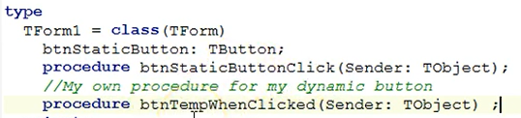

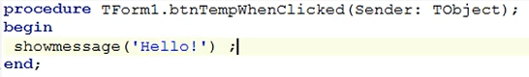

**STEP 5: Assign your method to the object’s event**

